Samara
By Marguerite de Messières and Tsvetomir Naydenov

Narrative and Description

Samara embodies the spirit of mechanical invention and architectural detail which pervades historic North Park. The canal, the pivot bridge, the lock, and the neighboring bridges all attest to the beautifully crafted and clever human solutions for getting valuable cargo over and through a complex natural landscape. As our muse, we take the maple samara, or whirligig, nature’s own mechanical wonder for carrying maple seeds across the same landscape. We propose a hollow-form steel sculpture full of crafted details and intersections, with bright touches of color in durable vitreous enamel. Several points of rotation will allow the piece to move in interesting and surprising ways at this windy site, while the height will allow visitors to jump and spin the piece with the main mechanisms safely above head height.

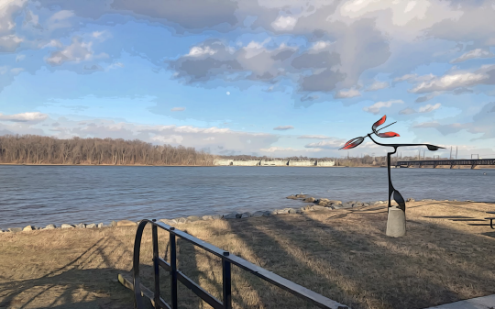

Illustration of potential siting of Samara

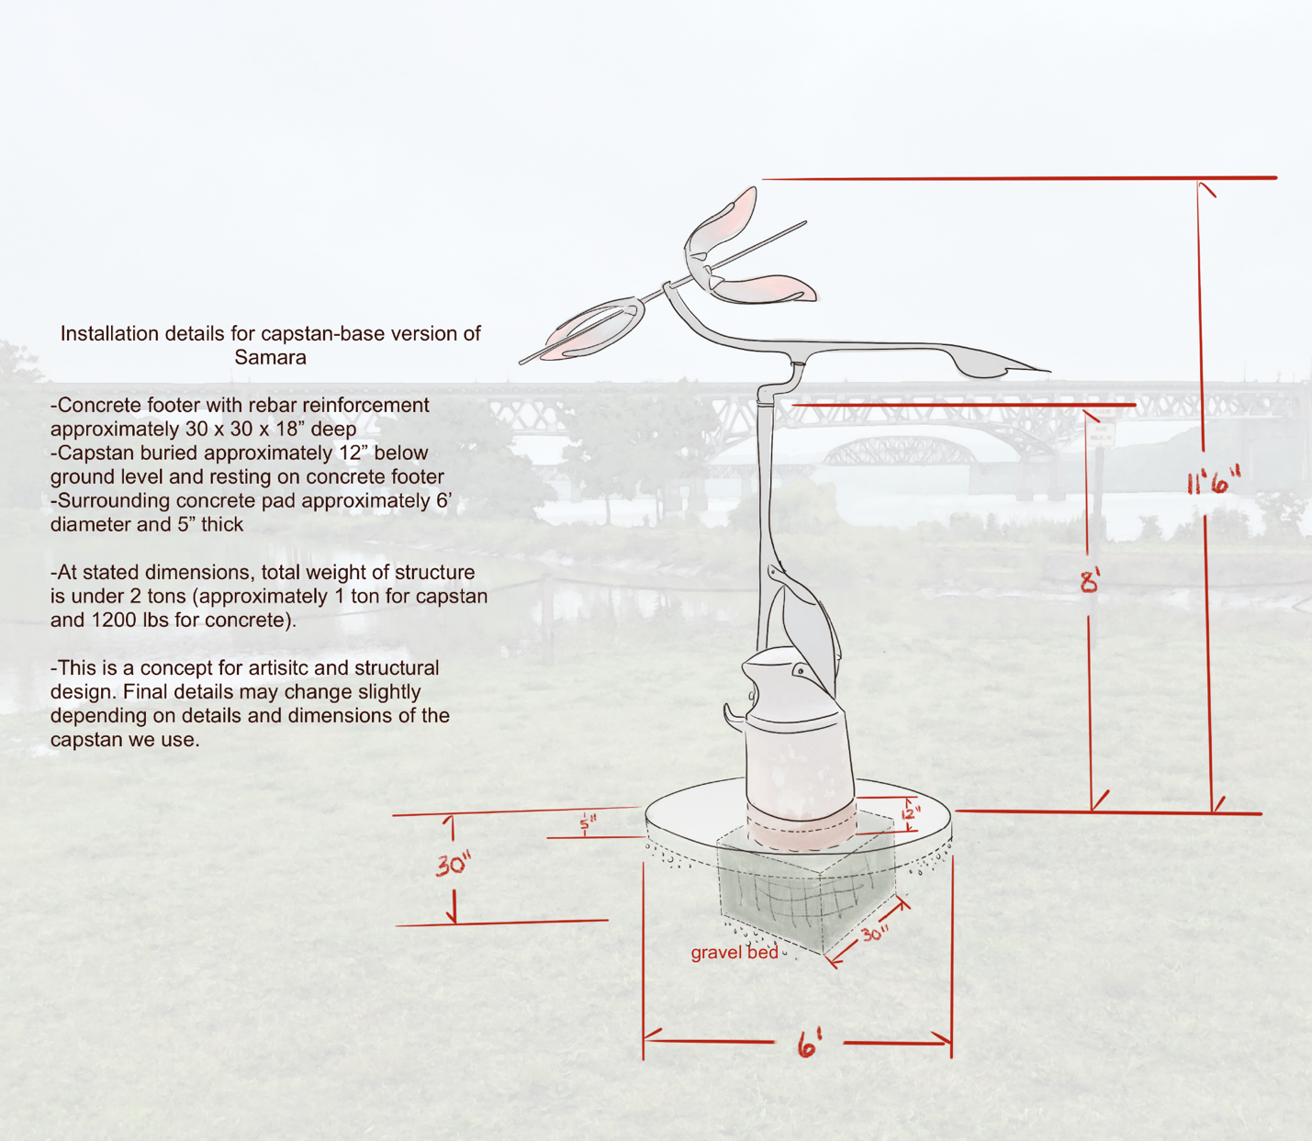

Technical Drawing of Samara

Installation Details

Installation:
This will not be a particularly heavy sculpture, but it will catch the wind. Anchoring the frame with bolts into the pedestal (with a footer as indicated in the drawing above) will provide long-term stability. Bolting the frame of the sculpture both down and through the side will give solid strength to the installation. The concrete base and footerwill have an inner rebar cage reinforcement.
Dimensions: 11’6” x 10’ x 5’

Materials:
Main forms: hollow-form mild steel, patinated and sealed Bearings
(permanently lubricated, stainless steel)
Color: torch-fired vitreous enamel
Base pedestal: steel capstan, concrete with rebar inner cage

Maintenance and Durability:
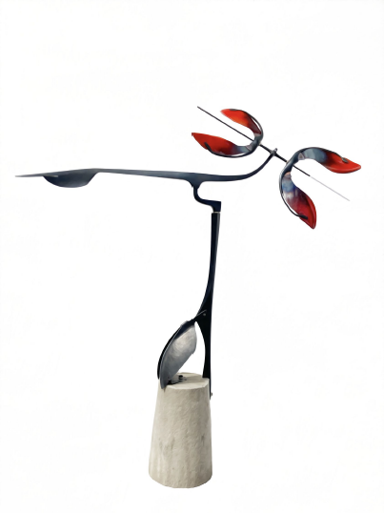
This piece is designed to last for decades with minimal care. Vitreous enamel is exceptionally durable and resists fading. Bearings will be corrosion resistant. Occasionally greasing the bearings and cleaning off the main forms would be beneficial. The main shapes will have a sealed patina, and will continue to oxidize into a richer patina over time. Artists warranty the art for one year. Havre de Grace will own the artwork upon installation and agrees to notify artists if there is a problem or significant damage to the sculpture.

Model of proposed sculpture, Samara, created for Havre de Grace.

